**NC Board of Transportation**

**US 70 Workgroup**

**December 1, 2016**

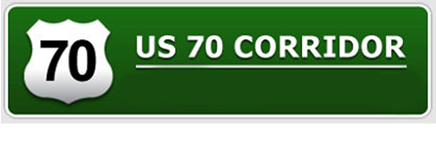





**Bypasses**

**Corridor Upgrades**

**Feasibility Studies**

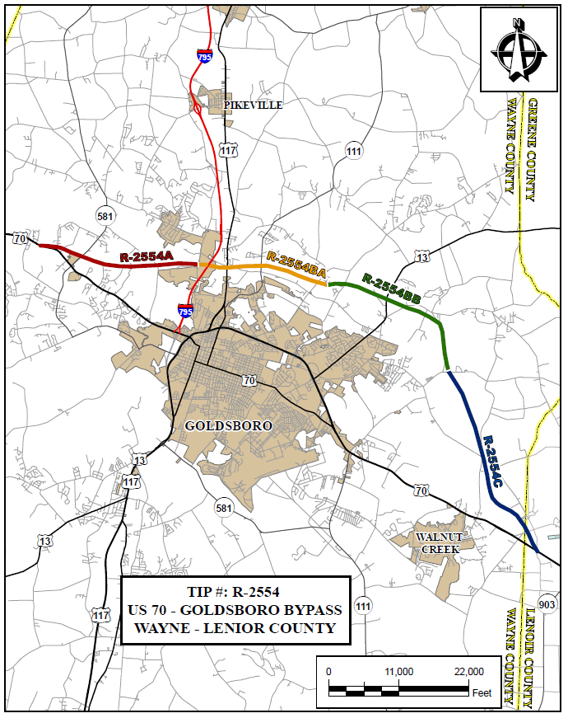

**US 70 Bypasses**

**Goldsboro Bypass (R-2554)**

**Funding Status:**

Complete

**Schedule:**

* + - Record of Decision Approved – August 1998
    - Section A
      * Opened to traffic October 17, 2015
    - Section BA
      * Opened to traffic Dec. 16, 2011
    - Sections BB & C
      * Opened to traffic May 27, 2016

**Activities Underway**

Entire Bypass: Construction of Intelligent Transportation System infrastructure to aid daily and emergency traffic flow. This consists of closed circuit cameras, DMS Boards, etc… Expected completion late 2016. Work has been slowed due to Hurricane Matthew. 79.2% Complete.

Project Manager: Brandon Herring, PE, (919) 209-1090, [blherring@ncdot.gov](mailto:blherring@ncdot.gov)

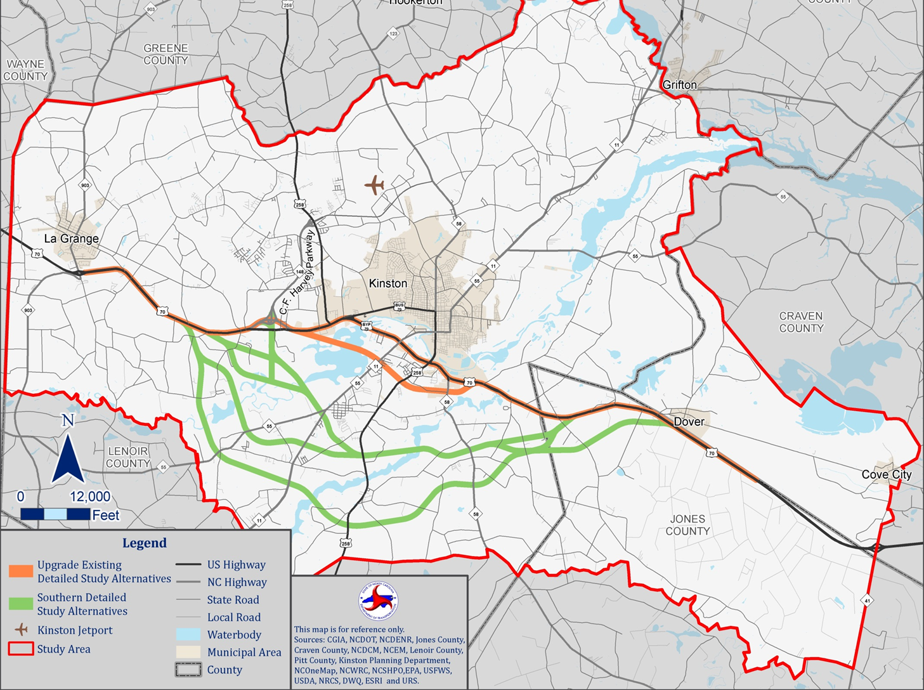

**R-2553 Kinston Bypass: Revised Corridor Map**

**Kinston Bypass (R-2553)**

**Funding Status:**

Unfunded in 2016-2025 STIP.

**Schedule:**

* + - Start-of-Study Letter – May 29, 2009
    - Purpose & Need (CP1) Concurrence Achieved – October 13, 2010
* Detailed Study Alternatives (CP2) Concurrence Achieved – November 17, 2011
* Environmental Studies for historic resources, natural resources, and community impacts – 2012 through 2016
* CP2 Concurrence (revisited) – January 16, 2014
* Bridging Decisions (CP2A) – April 17, 2014
* Draft Environmental Impact Statement - * winter 2016
* Corridor Design Public Hearing – TBD
* Corridor Selection (CP3) – TBD
* Delineation of wetlands and streams – *TBD
* Avoidance and Minimization (CP4A) – *TBD
* Final Environmental Impact Statement – *TBD
* State Record of Decision – *TBD
  + - Right of Way acquisition – (STIP: unfunded)
    - Construction – (STIP: unfunded)

**Activities Underway/Completed**

* + - Environmental Studies for Detailed Study Alternatives.
    - Functional Designs for Detailed Study Alternatives are completed.
    - Preliminary Noise Analysis is completed.
    - Public Meeting(s) #4 – were held August 26th & 28, 2014.
    - Local Officials Meeting #6 was held August 26, 2014.
    - Land Use Scenario Assessment was finalized in August 2015
    - Estimates completed: Utilities, Construction, ITS, relocation impacts.
    - Draft Economic Impact Assessment is being revised by AECOM per NCDOT comments.
    - Traffic Forecast underway (detailed traffic forecasts for all alternatives).
    - Right of way cost estimate underway – completion Winter 2016.
    - Draft EIS now being assembled & written, expect 1st rough draft in winter 2016.
    - NCDOT-PDEA and FHWA are currently working on “lessons learned” for the GIS Pilot project & devising the best means for bringing that study to a close.

**Upcoming Actions**

* + - Rough draft of Draft EIS to be completed winter 2016

Project Owner: John Rouse, P.E., (252) 439-2800, jwrouse@ncdot.gov

Project Manager: Brian Yamamoto, P.E., (919) 707-6051, [byamamoto@ncdot.gov](mailto:byamamoto@ncdot.gov)

Bob Deaton, (919) 707-6017, rdeaton@ncdot.gov

*\*Notes: Kinston Bypass is unfunded in the STIP. Decisions regarding further scheduling activities are To Be Determined (TBD).*

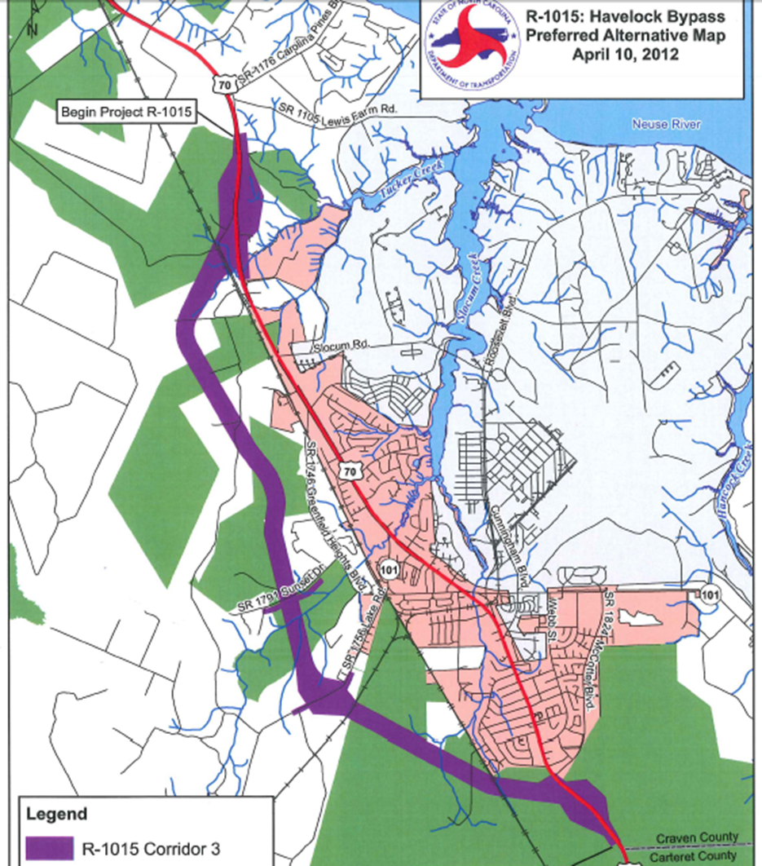

**Havelock Bypass (R-1015)**

**Funding Status:**

All segments funded for both right of way and construction in2016-2025 STIP.

**Schedule:**

* + - Draft Environmental Impact Statement – approved Sept. 2011
    - Corridor Public Hearing – December 6, 2011
    - Conducted Post Hearing Meeting – Feb. 2012
    - Concurrence Point 3 Meeting (Corridor Selection Revisited) – Concurrence Achieved on April 10, 2012
    - Concurrence Point 2A (Bridging Decisions Revisited) – Concurrence Achieved on July 9, 2012
    - Environmental Studies Updates – 2012 - 2015
    - Concurrence Point 4A (Avoidance & Minimization) – August 2014
    - Final EIS Approved (FHWA) **–** Oct. 2015
    - Record of Decision – Winter 2016
    - Right of Way acquisition – FY 2016
    - Construction – FY 2018

**Activities Underway/Completed**

* Final EIS approved October 2015.
  + - MOU that establishes parameters of USFS management of Croatan Wetland Mitigation Bank awaiting USFS legal review.
* ITS plan for bypass closure during burns completed.

**Upcoming Actions**

* + - Receive comments on updated MOU for CWMB management by USFS.
    - Address FHWA legal comments on draft Record of Decision (ROD).

Project Manager: John Conforti, REM, (919) 707-6015, [jgconforti@ncdot.gov](mailto:byamamoto@ncdot.gov)

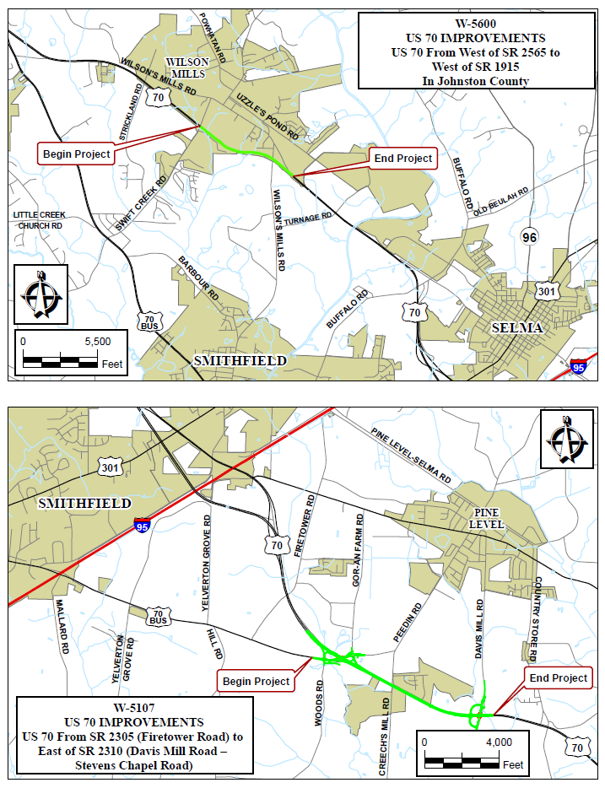

**US 70 Corridor Upgrades**

**US 70 Improvements near Wilson’s Mills, Johnston County,**

**W-5600**

Upgrade US 70 to a freeway from US 70 Clayton Bypass to Neuse River bridge. Construct interchanges at Swift Creek Road and Wilson’s Mill Road.

**Funding Status:**

Fully funded in 2016-2025 STIP.

**Schedule:**

* + - Project Scoping Meeting – Held July 2012
    - Categorical Exclusion – June 2016
    - Right of Way Acquisition – FY 2018
    - Construction – FY 2020

**Activities Underway**

* + - Public meeting conducted February 2, 2016.
    - CE Completed June 2016

**Upcoming Actions**

* Development of Preliminary Roadway Design Plans by PEF.

Project Manager:    Jerry Page, PE (252) 237-6164, [jpage@ncdot.gov](mailto:jpage@ncdot.gov);

**US 70 Improvements near Pine Level, Johnston County, W-5107**

Median cross-over closures and upgrades of two intersections to interchanges.

**Funding Status:**

Fully funded in 2016-2025 STIP

**Schedule:**

* + - Categorical Exclusion Document – Approved February 2012
    - Construction – Project let to construction February 2015
      * Estimated Completion January 2018

**Activities Underway**

* Construction is underway (47% complete).
* Set steel girders on US 70 Alternate at Collins Marine.
* Will set concrete girders at Davis Mill Road in early 2017.

Project Manager: Bobby Liverman, PE (252) 459-2129, [blliverman@ncdot.gov](mailto:blliverman@ncdot.gov)

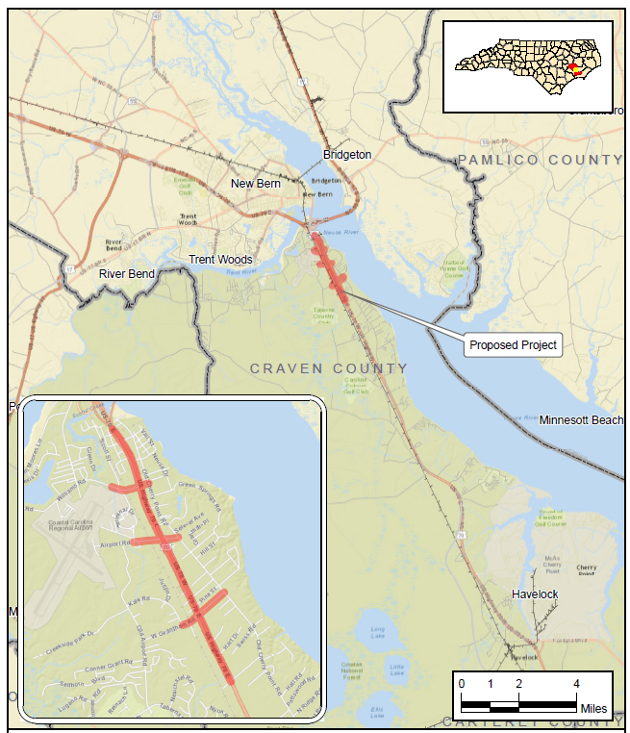

**US 70 Improvements in James City, Craven County, U-5713**

**US 70 Improvements in James City, Craven County, U-5713**

Upgrade US 70 to freeway standards.

**Funding Status:**

Fully funded in 2016-2025 STIP

**Schedule:**

* + - Feasibility Studies prepared – 2010, 2012, 2014
    - Environmental Assessment – FY 2018
    - FONSI – FY 2020
    - Design/Build Let – FY 2021

**Activities Underway/Completed**

* Internal scoping meeting held Jan 28, 2015.
* Individual interviews with citizens and businesses held Aug 2015.
* Focus group meetings held Sep 2015.
* Public meetings (1st round) held Oct 2015.
* NRTR/Wetland Delineations complete Nov 30 2015.
* Traffic Forecast complete Jul 12, 2016
* External Scoping Meeting Sep 2016.
* Merger Screening Meeting held Sep 12, 2016 (exempt from Merger).
* Conceptual Alternatives developed Sep 2016.

**Upcoming Actions**

* Public meetings (2nd round) to be held December 5-6 2016 - to show preliminary design concepts.
* Confirm alternatives to be carried forward for detailed study (DSAs) - Winter 2017.
* Develop Preliminary Roadway Designs for DSAs - Fall 2017.
* Prepare draft of Environmental Assessment (EA) – Spring 2018.

Project Manager: John Conforti, REM, (919) 707-6015, [jgconforti@ncdot.gov](mailto:byamamoto@ncdot.gov)

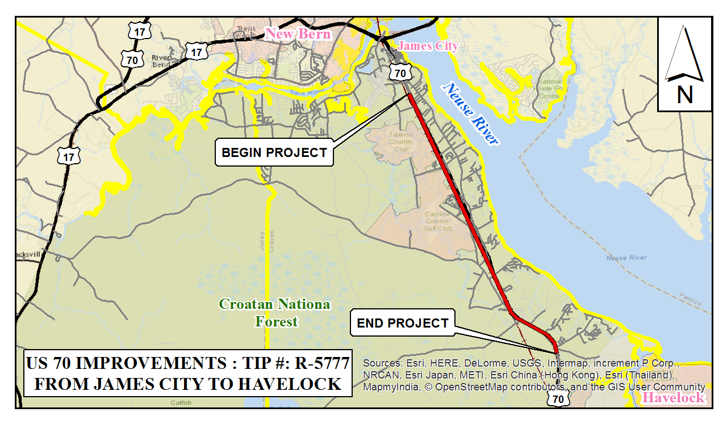

**US 70 Improvements from James City to Havelock, Craven County, R-5777**

Upgrade US 70 to freeway standards, including construction of service roads and interchanges.

**Funding Status:**

Recently funded in 2016-2025 STIP (Right of Way only)

**Schedule:**

* + - State Environmental Assessment – FY 2022
    - State FONSI – FY 2023
    - Right of Way Acquisition – SFY 2025
    - Construction – Post Year

**Upcoming Actions**

* Project adjustments currently being considered in association with P 4.0 process for STI. Taberna Way interchange has been selected in Statewide Category.
* Planning/Environmental study to begin in 2017.

Project Managers: Brian F. Yamamoto, PE (919) 707-6051, [byamamoto@ncdot.gov](mailto:byamamoto@ncdot.gov)

Jay McInnis, P.E., (919) 707-6029, [jmcinnis@ncdot.gov](mailto:jmcinnis@ncdot.gov)

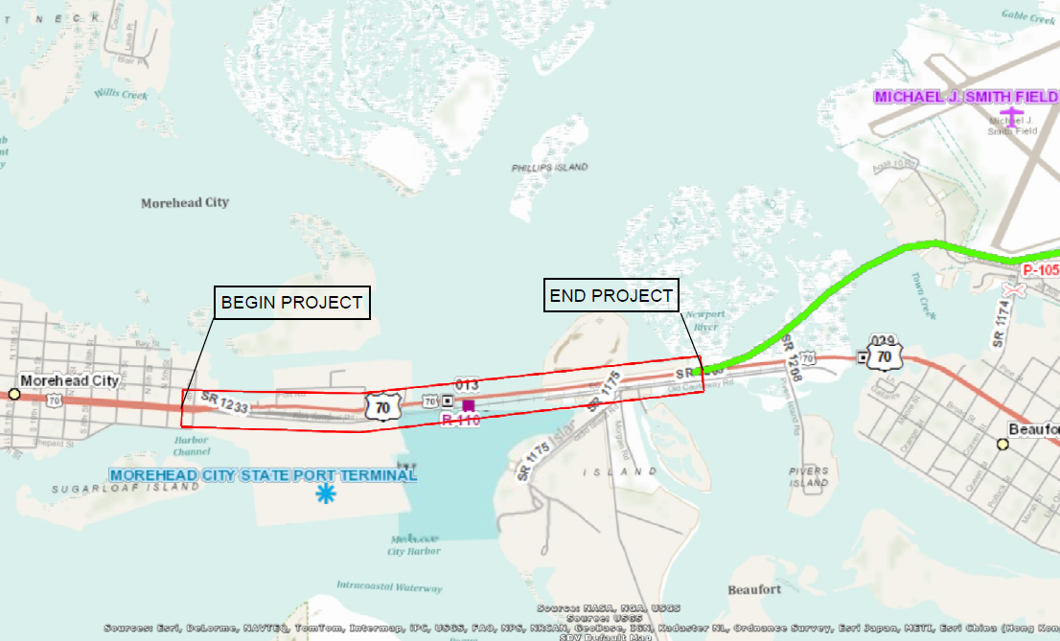

**U-5740 (Newport River Bridge) Project Study Area**

**US 70 Improvements in Morehead City (including the Widening of Newport River Bridge), Carteret County, U-5740/U-5876**

Widen US 70 and widen/upgrade bridge.

**Funding Status:**

Fully funded in 2016-2025 STIP

**Schedule:**

* + - State Environmental Assessment – FY 2020
    - State FONSI – FY 2021
    - Right of Way Acquisition – SFY 2022
    - Construction – SFY 2024

**Upcoming Actions**

* Project adjustments currently being considered in association with P 4.0 process for STI.
* Private Engineering Firm (RS&H) selected for SEPA study.
* Aerial orthophotography to be requested in Dec 2016.

Project Managers: Brian F. Yamamoto, PE (919) 707-6051, [byamamoto@ncdot.gov](mailto:byamamoto@ncdot.gov)

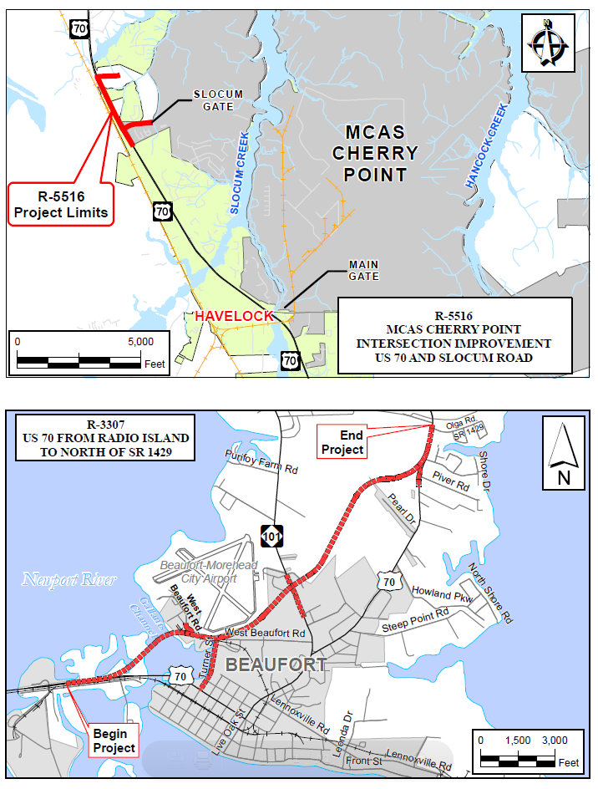

**Slocum Gate Improvements (MCAS Cherry Point, Havelock), Craven County, R-5516**

Construction of flyover on existing US 70 at Slocum Gate.

**Funding Status:**

Fully funded in Draft 2016-2025 STIP for ROW and LET.

**Schedule:**

* + - Categorical Exclusion – completed December 2013
    - Right of Way Acquisition – FY 2015
    - Construction – FY 2017

**Activities Underway/Completed**

* Categorical Exclusion Environmental Document – approved December 2013
* Begin Right of Way acquisition – June 2015
* Preparation of final roadway design plans ongoing

**Upcoming Actions**

* Complete construction consultation – March 2017
* Complete final roadway design plans – March 2017
* Complete right of way acquisition – May 2017
* Let project to construction – June 2017

Project Managers: Jay McInnis, PE, (919) 707-6029, [jmcinnis@ncdot.gov](mailto:jmcinnis@ncdot.gov)

Gary Lovering, P.E., (919) 707-6271, [glovering@ncdot.gov](mailto:glovering@ncdot.gov)

**US 70 Improvements in Beaufort (including Gallants Channel Bridge Replacement), Carteret County, R-3307**

**Funding Status:**

Under construction.

**Schedule:**

* + - Environmental Assessment – approved Oct. 2004
    - Finding of No Significant Impact – approved Sept. 2006
    - Right of Way Acquisition – complete
    - Project Let – January 2014
    - Estimated completion – Mid 2017

**Activities Completed**

* Coast Guard Permit approved – December 2013
* Project letting – January 2014
* Project under construction (Conti Enterprise Inc., contractor)
* Channel Span completed
* Retaining wall and noise walls completed
* Turner Street bridge piles installed

**Upcoming Actions**

* Grading for entire project is mostly complete. Tie-ins at the east and west side of existing US 70 not completed.
* Bridge construction in progress – concrete deck, expansion joints and barrier rail.
* Turner Street bridge concrete deck pours are occurring

Project Manager: Brad McMannen, PE, (252) 514-4759, [bmcmannen@ncdot.gov](mailto:bmcmannen@ncdot.gov)

**Feasibility Studies**

*Unfunded projects with a study to determine scope and general cost.*

**COMPLETED:**

**Kinston**

Conversion of existing US 70 intersection at NC 11/55 (Skinners Bypass) to an interchange

Feasibility Study completed March 2010 (US 70 Corridor Commission)

**James City to Havelock Bypass**

Near term and long term US 70 corridor improvements

Feasibility Study completed January, 2012.

**Northern Carteret Bypass, R-4431**

New location freeway

Feasibility Study completed September 2, 2009 (Memo Update), July 22, 2009 (Feasibility Study Report).

**US 70 from New Bern to Proposed Havelock Bypass**

Construct freeway on New Location in Craven County Report complete Oct. 2014.

**US 70 from Johnston County Line to Proposed US 70 Goldsboro Bypass, Wayne County**

Upgrade to freeway

Feasibility Study completed November, 2015.

**US 117 (Future I-795) from US 70 in Goldsboro to I-40, Wayne, Duplin and Sampson Counties**

Upgrade to freeway

Report completed July, 2015.

**Morehead City to Beaufort**

Widening of existing US 70 causeway

Final report completed - February 2016.

**UNDERWAY:**

**Kinston (Queen Street Interchange)**

Conversion of existing US 70 intersection at US 258 (Queen Street) to an interchange

Updated traffic forecast received November 14, 2016. Conceptual designs scheduled for Spring, 2017. Anticipated Feasibility Study completion – late 2017.

**US 70 from Princeton to I-95 in Selma, Johnston County.**

Upgrade to Freeway (Interstate Standard).

Consultant firm began work in March, 2016. Conceptual designs underway. Design review meeting anticipated late Spring 2017. Final Feasibility Study anticipated late 2017.

NCDOT contact for Feasibility Studies: Derrick Lewis, P.E., (919) 707-4663, [dlewis@ncdot.gov](mailto:dlewis@ncdot.gov)

